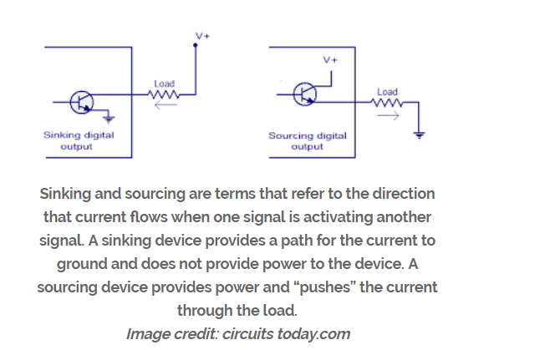

https://electronics.stackexchange.com/questions/280248/why-would-you-need-both-a-pullup-resistor-and-a-capacitor-to-ground-on-an-io-pin
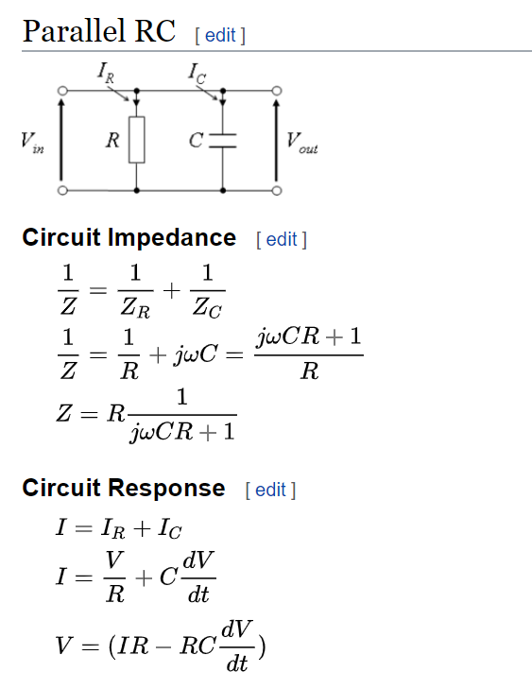

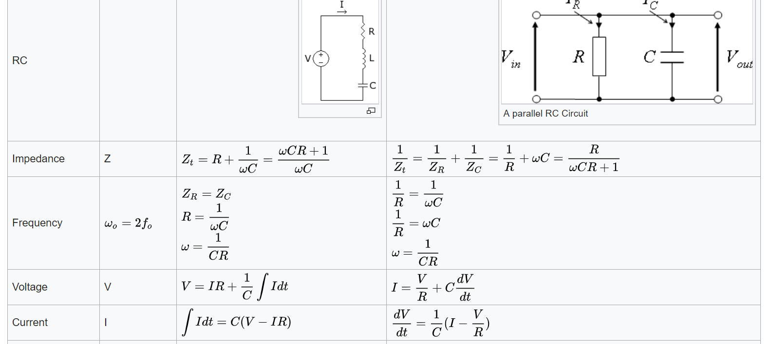

https://www.physicsforums.com/threads/constant-current-source-in-driving-an-rc-circuit.965796/

parallel rc with current source

